

**University of Information Technology and Management in Rzeszow**

**Software Engineering**

**Theme of the project:**

***Taxi app***

**Project team:**

**Ardasher Mamadrizobekov w63447**

**Teacher: dr inż. Maksymilian Knap**

**Rzeszów 2023**

The theme of this project is an “MargulanTaxiApp”.

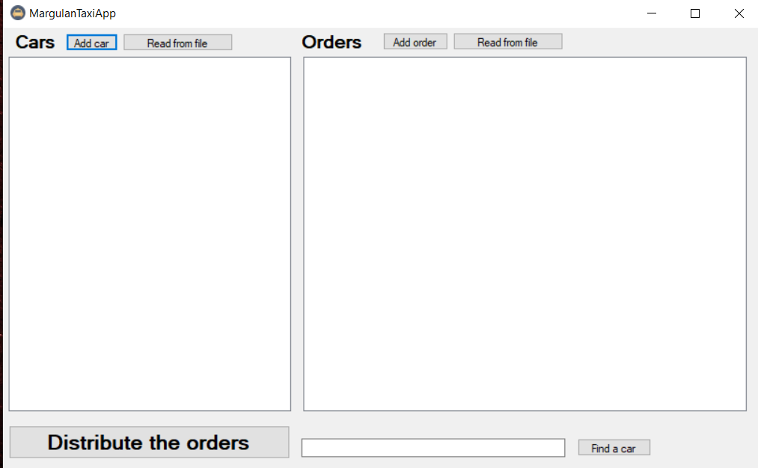

As you can see there you can add cars, receive an orders and distribute them.In the left side of app you can add cars which will work in that day:

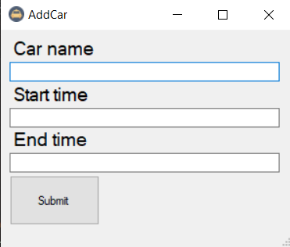

You need to enter the name of the car, the start time - the start time of the driver's work day and the end time of the work day.

In the right side of app you will receive an orders from custemers and we, in turn, will add information about the trip to our database:

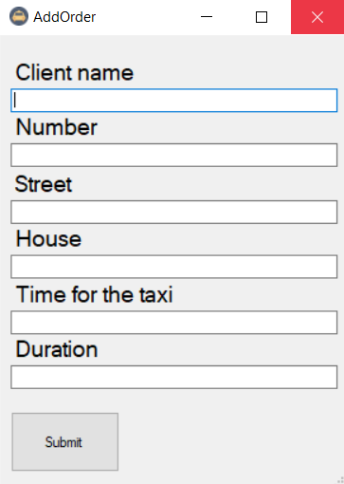

You need enter client name, number, street,house,time when driver come and duration of trip.

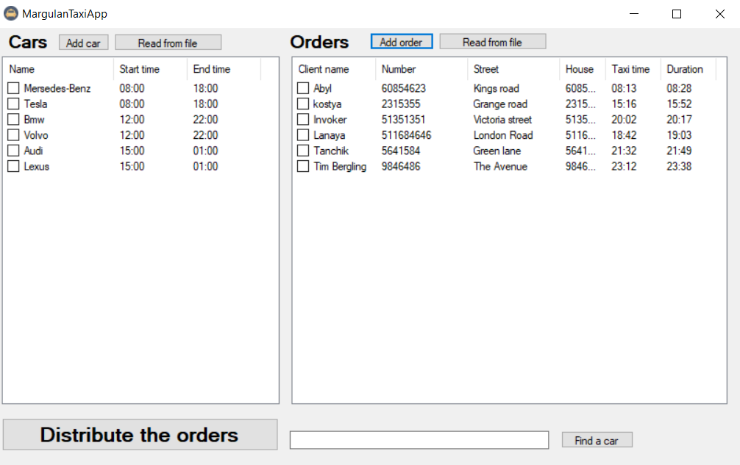

At the end is the "Distribute" button. This button shows which car driver made which trip, where, what time of departure and time of arrival.

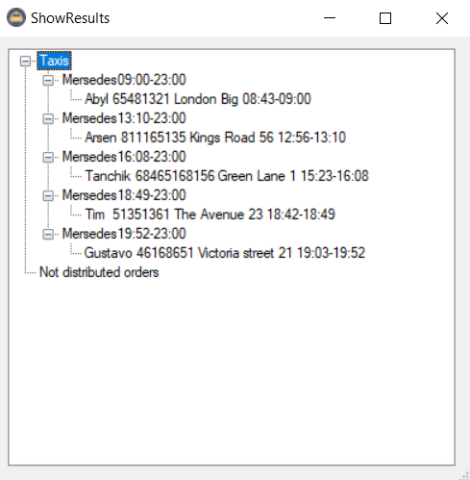

Cods:

Code: MainForm:

using System;

using System.Collections.Generic;

using System.ComponentModel;

using System.Data;

using System.Drawing;

using System.Linq;

using System.Text;

using System.Threading.Tasks;

using System.Windows.Forms;

namespace MargulanTaxiApp

{

public partial class MainForm : Form

{

public MainForm()

{

InitializeComponent();

}

private void label1_Click(object sender, EventArgs e)

{

}

private void label2_Click(object sender, EventArgs e)

{

}

private void label3_Click(object sender, EventArgs e)

{

}

private void checkedListBox1_SelectedIndexChanged(object sender, EventArgs e)

{

}

private void listView1_SelectedIndexChanged(object sender, EventArgs e)

{

}

private void button5_Click(object sender, EventArgs e)

{

// Add car from file

if (openFileDialog1.ShowDialog() == DialogResult.Cancel)

return;

// Open files

string filename = openFileDialog1.FileName;

string fileText = System.IO.File.ReadAllText(filename);

string[] fileTextSplited = fileText.Split('\n');

// Data validation

try

{

// Loop for each row

foreach (var item in fileTextSplited)

{

// Parse the file

string[] vs = item.Split(' ');

// Add car to cars

Car car = new Car(vs[0], DateTime.Parse(vs[1]), DateTime.Parse(vs[2]));

cars.Add(car);

}

}

// Error message

catch

{

MessageBox.Show("This data already exist");

return;

}

// view new car

this.listView1.Clear();

if (listView1.Columns.Count == 0)

{

listView1.Columns.Add("Name", 120);

listView1.Columns.Add("Start time", 80);

listView1.Columns.Add("End time", 80);

}

List<ListViewItem> ListItems = new List<ListViewItem>();

foreach (var i in cars)

{

ListViewItem item = new ListViewItem(i.getCarName());

item.SubItems.Add(i.getStartTime().ToString("HH:mm"));

item.SubItems.Add(i.getEndTime().ToString("HH:mm"));

ListItems.Add(item);

}

this.listView1.Items.AddRange(ListItems.ToArray());

}

private void openFileDialog1_FileOk(object sender, CancelEventArgs e)

{

}

private void button3_Click(object sender, EventArgs e)

{

// Add order form method

AddOrder addOrderForm = new AddOrder();

addOrderForm.ShowDialog();

// Data validation

if (addOrderForm.DialogResult == DialogResult.OK)

{

// Add new order to orders

Order order = addOrderForm.returnOrder();

orders.Add(order);

// Add items to ListView

ListViewItem item = new ListViewItem(order.getClientName());

item.SubItems.Add(order.getNumber().ToString());

item.SubItems.Add(order.getStreet());

item.SubItems.Add(order.getNumber().ToString());

item.SubItems.Add(order.getStartTime().ToString("HH:mm"));

item.SubItems.Add(order.getEndTime().ToString("HH:mm"));

// View new order

if (listView2.Columns.Count == 0)

{

listView2.Columns.Add("Client name", 90);

listView2.Columns.Add("Number", 100);

listView2.Columns.Add("Street", 100);

listView2.Columns.Add("House", 50);

listView2.Columns.Add("Taxi time", 60);

listView2.Columns.Add("Duration", 60);

}

this.listView2.Items.Add(item);

}

}

private void button1_Click(object sender, EventArgs e)

{

// Add car form method

AddCar addCarForm = new AddCar();

addCarForm.ShowDialog();

// If fields are valid

if (addCarForm.DialogResult == DialogResult.OK)

{

// Add new car to cars

Car car = addCarForm.returnCar();

cars.Add(car);

// View new car in ListView

ListViewItem item = new ListViewItem(car.getCarName());

item.SubItems.Add(car.getStartTime().ToString("HH:mm"));

item.SubItems.Add(car.getEndTime().ToString("HH:mm"));

// View new car

if (listView1.Columns.Count == 0)

{

listView1.Columns.Add("Name", 120);

listView1.Columns.Add("Start time", 80);

listView1.Columns.Add("End time", 80);

}

this.listView1.Items.Add(item);

}

}

private void button7_Click(object sender, EventArgs e)

{

// Result form method

if (this.orders.Count == 0 || this.cars.Count == 0)

{

MessageBox.Show("Enter orders or cars");

}

else

{

ShowResults showResultsForm = new ShowResults(cars, orders);

showResultsForm.ShowDialog();

}

}

private void label1_Click_1(object sender, EventArgs e)

{

}

private void label2_Click_1(object sender, EventArgs e)

{

}

private void button4_Click(object sender, EventArgs e)

{

}

private void button6_Click(object sender, EventArgs e)

{

// Add orders from file method

if (openFileDialog1.ShowDialog() == DialogResult.Cancel)

return;

// Read file

string filename = openFileDialog1.FileName;

string fileText = System.IO.File.ReadAllText(filename);

string[] fileTextSplited = fileText.Split('\n');

// Data validation check

try

{

// Loop every row

foreach (var stringOfFile in fileTextSplited)

{

// Parse data

string[] vs = stringOfFile.Split(' ');

int minutes = Convert.ToInt32(vs[5]);

DateTime newDate = DateTime.Parse(vs[4]).AddMinutes(minutes);

// Add order to Orders

Order order = new Order(vs[0], vs[1], vs[2], vs[3], DateTime.Parse(vs[4]), newDate);

orders.Add(order);

}

}

catch

{

// Error message

MessageBox.Show("This data already exist");

return;

}

// view new car

this.listView2.Clear();

// View new order

if (listView2.Columns.Count == 0)

{

listView2.Columns.Add("Client name", 90);

listView2.Columns.Add("Number", 100);

listView2.Columns.Add("Street", 100);

listView2.Columns.Add("House", 50);

listView2.Columns.Add("Taxi time", 60);

listView2.Columns.Add("Duration", 60);

}

List<ListViewItem> ListItems = new List<ListViewItem>();

foreach (var i in orders)

{

// Add items to ListView

ListViewItem item = new ListViewItem(i.getClientName());

item.SubItems.Add(i.getNumber().ToString());

item.SubItems.Add(i.getStreet());

item.SubItems.Add(i.getHouse().ToString());

item.SubItems.Add(i.getStartTime().ToString("HH:mm"));

item.SubItems.Add(i.getEndTime().ToString("HH:mm"));

ListItems.Add(item);

}

this.listView2.Items.AddRange(ListItems.ToArray());

}

private void button2_Click(object sender, EventArgs e)

{

// Find a car, search box

if (this.textBox1.Text.Length > 0)

{

// Search method

var thisTag = cars.FirstOrDefault(t => t.getCarName() == this.textBox1.Text);

// If it found

if (thisTag.getCarName() != null)

{

MessageBox.Show(thisTag.getCarName() + " " + thisTag.getStartTime().ToString("HH:mm") +

" " + thisTag.getEndTime().ToString("HH:mm"));

}

else

{

MessageBox.Show("Not found");

}

}

else

{

MessageBox.Show("Enter text");

}

}

}

}

AddCar:

using System;

using System.Collections.Generic;

using System.ComponentModel;

using System.Data;

using System.Drawing;

using System.Linq;

using System.Text;

using System.Threading.Tasks;

using System.Windows.Forms;

namespace MargulanTaxiApp

{

public partial class AddCar : Form

{

public AddCar()

{

InitializeComponent();

}

private void Yes_Click(object sender, EventArgs e)

{

// fields text check

if (textBox1.TextLength > 0 && textBox2.TextLength > 0 && textBox3.TextLength > 0)

{

// time validation check

try

{

DateTime startTime = DateTime.Parse(textBox2.Text);

DateTime endTime = DateTime.Parse(textBox3.Text);

Car car = new Car(textBox1.Text, startTime, endTime);

this.car = car;

this.DialogResult = DialogResult.OK;

}

catch

{

// error message

MessageBox.Show("Enter time correctly");

return;

}

}

// error message

else

MessageBox.Show("Enter values");

}

public Car returnCar()

{

return (this.car);

}

private void Yes_KeyPress(object sender, KeyPressEventArgs e)

{

}

}

}

AddOrder:

using System;

using System.Collections.Generic;

using System.ComponentModel;

using System.Data;

using System.Drawing;

using System.Linq;

using System.Text;

using System.Threading.Tasks;

using System.Windows.Forms;

namespace MargulanTaxiApp

{

public partial class AddOrder : Form

{

public AddOrder()

{

InitializeComponent();

}

private void label2_Click(object sender, EventArgs e)

{

}

private void button1_Click(object sender, EventArgs e)

{

// Check is fields are full

if (textBox1.TextLength > 0 && textBox2.TextLength > 0 && textBox3.TextLength > 0

&& textBox4.TextLength > 0 && textBox5.TextLength > 0

&& textBox6.TextLength > 0)

{

// Time validation

try

{

DateTime startTime = DateTime.Parse(textBox5.Text);

int minutes = Convert.ToInt32(textBox6.Text);

DateTime endTime = DateTime.Parse(textBox5.Text).AddMinutes(minutes);

order = new Order(textBox1.Text, textBox2.Text, textBox3.Text,

textBox4.Text, startTime, endTime);

this.DialogResult = DialogResult.OK;

}

// Error message

catch

{

MessageBox.Show("Enter time correctly");

return;

}

}

// Error message

else

MessageBox.Show("Enter values");

}

public Order returnOrder()

{

return this.order;

}

private void textBox6_TextChanged(object sender, EventArgs e)

{

}

private void textBox2_TextChanged(object sender, EventArgs e)

{

}

private void textBox4_TextChanged(object sender, EventArgs e)

{

}

}

}

Order:

using System;

using System.Collections.Generic;

using System.Linq;

using System.Text;

using System.Threading.Tasks;

namespace MargulanTaxiApp

{

public class Order

{

// consturctor with arguments

public Order(string clientName, string number, string street,

string house, DateTime startTime, DateTime endTime)

{

this.clientName = clientName;

this.number = number;

this.street = street;

this.house = house;

this.startTime = startTime;

this.endTime = endTime;

}

// mock constructor

public Order()

{

}

// get client name method

public string getClientName()

{

return this.clientName;

}

// get client's number method

public string getNumber()

{

return this.number;

}

// get client's street method

public string getStreet()

{

return this.street;

}

// get client's house method

public string getHouse()

{

return this.house;

}

// get client's time for taxi method

public DateTime getStartTime()

{

return this.startTime;

}

// get client's duration

public DateTime getEndTime()

{

return this.endTime;

}

// order fields

private string clientName;

private string number;

private string street;

private string house;

private DateTime startTime;

private DateTime endTime;

}

}

Car:

using System;

using System.Collections.Generic;

using System.Linq;

using System.Text;

using System.Threading.Tasks;

namespace MargulanTaxiApp

{

public class Car

{

// constructor with arguments

public Car(string carName, DateTime startTime, DateTime endTime)

{

this.carName = carName;

this.startTime = startTime;

this.endTime = endTime;

}

// mock constructor

public Car()

{

}

// get car name method

public string getCarName()

{

return this.carName;

}

// get car start time method

public DateTime getStartTime()

{

return this.startTime;

}

// get car end time

public DateTime getEndTime()

{

return this.endTime;

}

// set car start time

public void setStartTime(DateTime time)

{

this.startTime = time;

}

// car fields

private string carName;

private DateTime startTime;

private DateTime endTime;

}

}